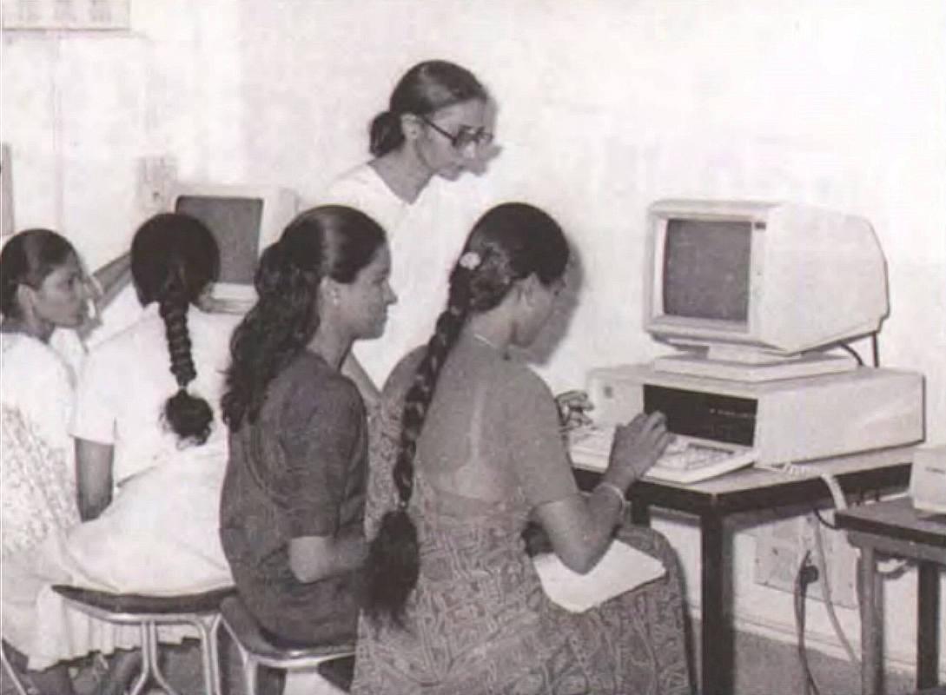

1986

Inauguration Of the First Computer Centre

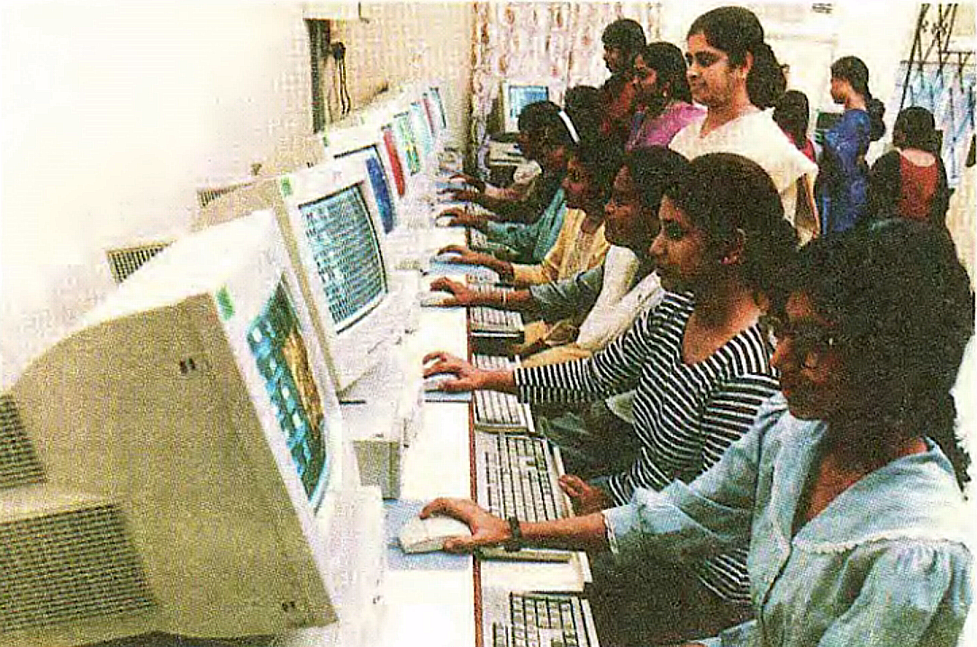

1986-88

Introduction Of Post Graduate Diploma in Computer Programming and Short-Term Courses

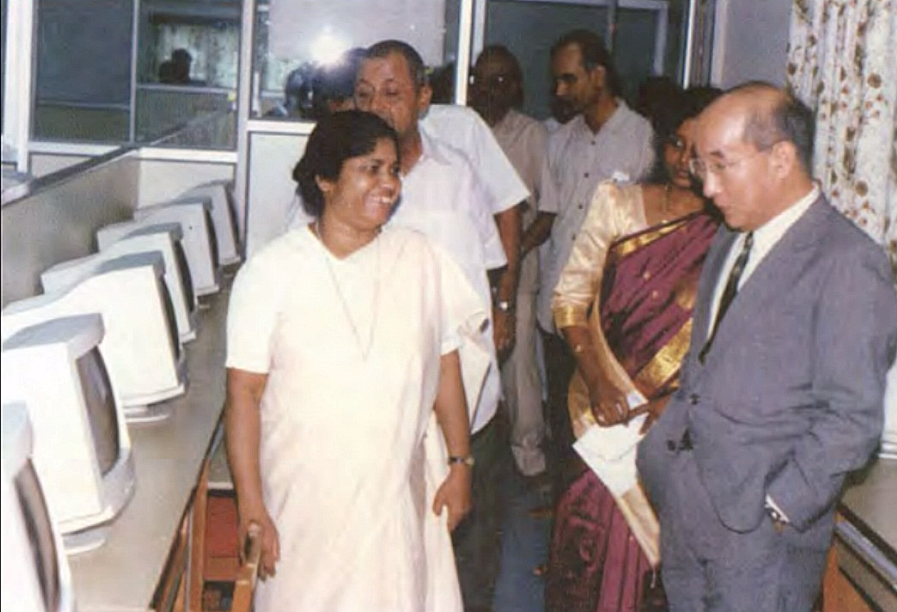

1998

Introduction Of BCA Two State-Of-The-Art Labs

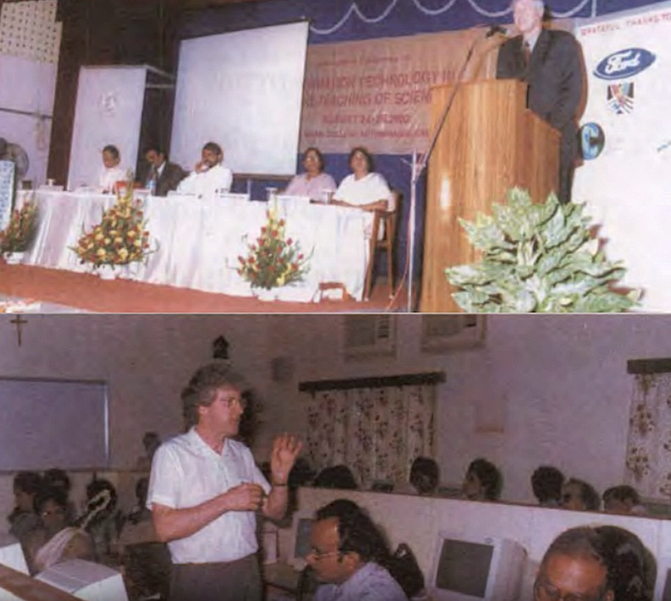

2000

International Conference on Information Technology in The Teaching of Science

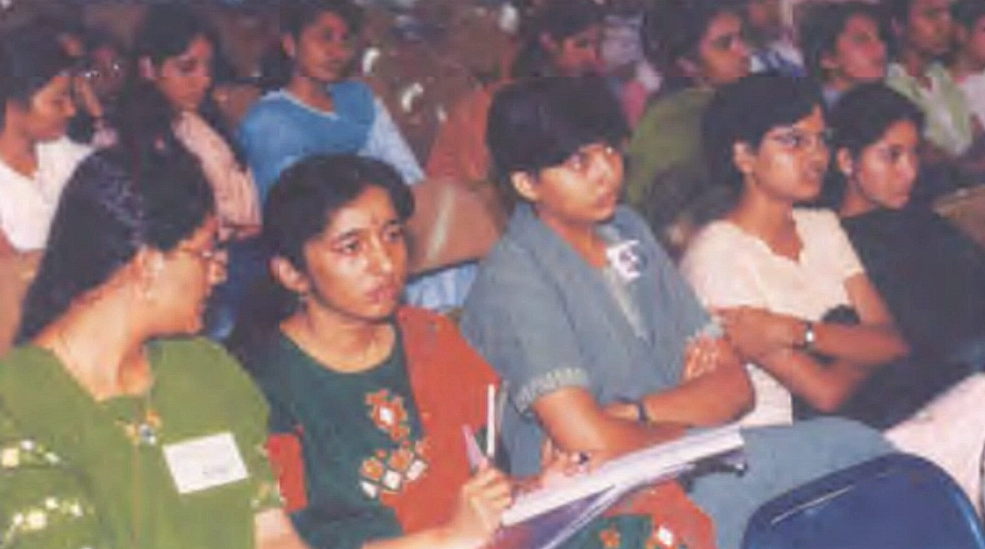

2000

First Edition of The Inter-Collegiate Department Fest, Wizit

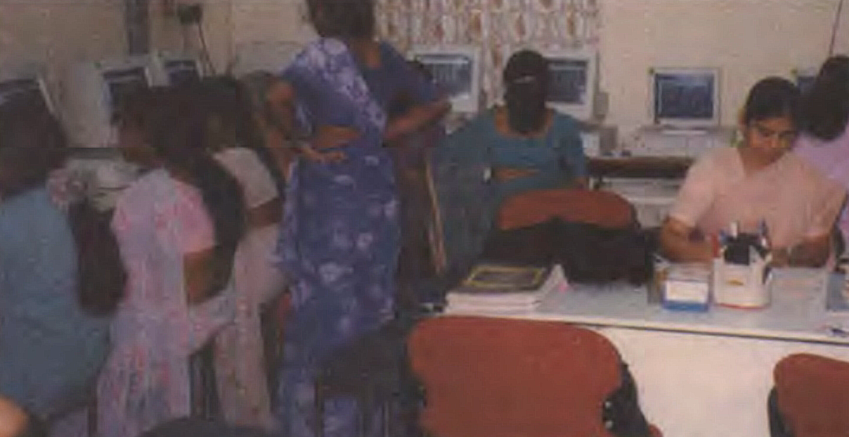

2001

Introduction Of Master of Science in Information Technology

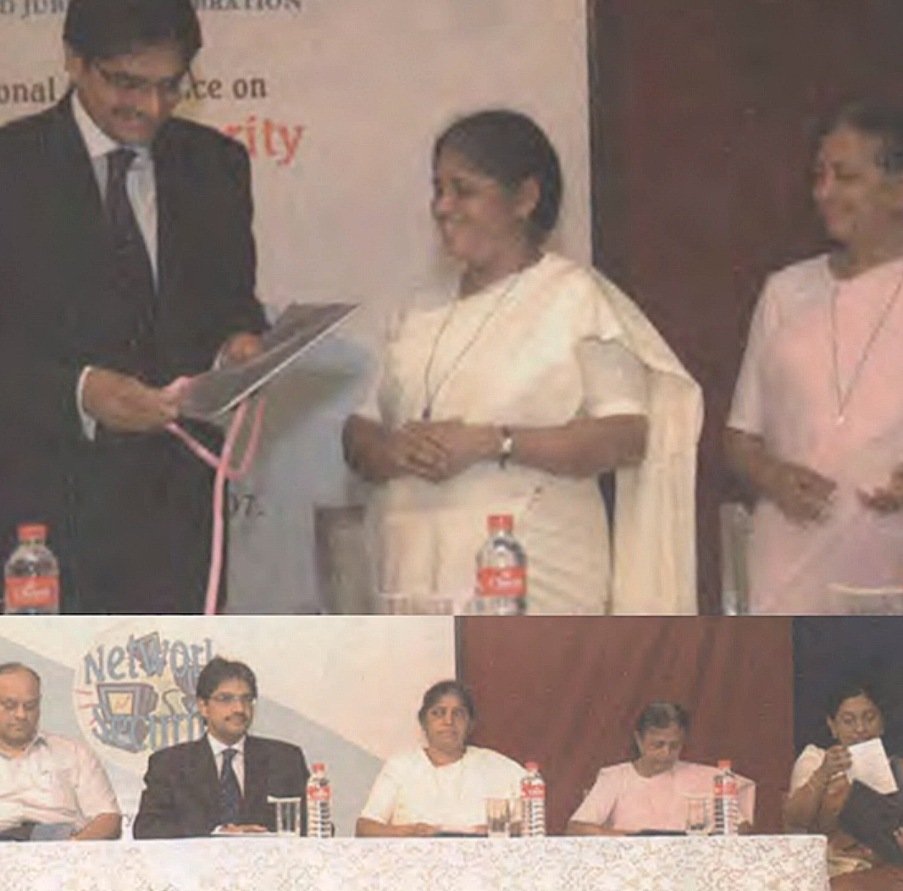

2007

First National Conference on Network Security

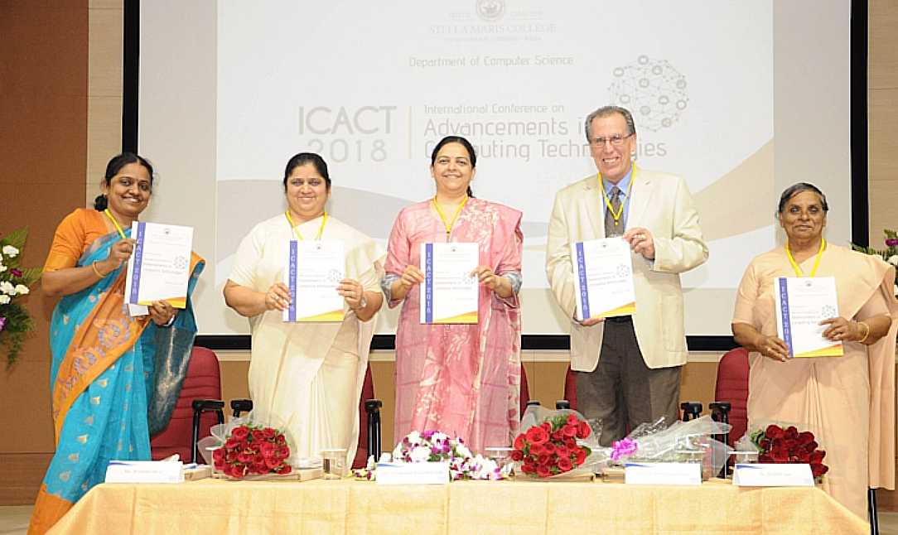

2018

First International Conference on Advancements in Computing Technologies

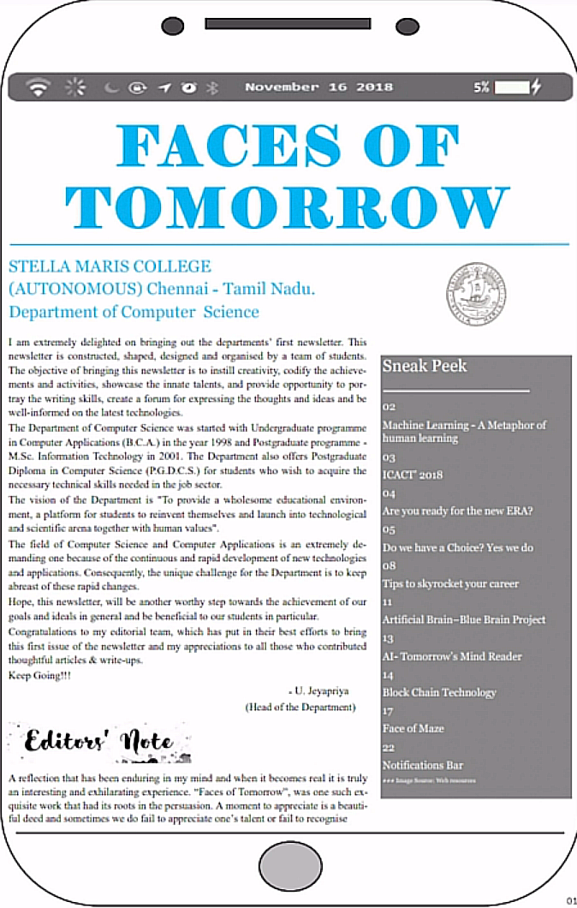

2018

First Edition of The Department Newsletter

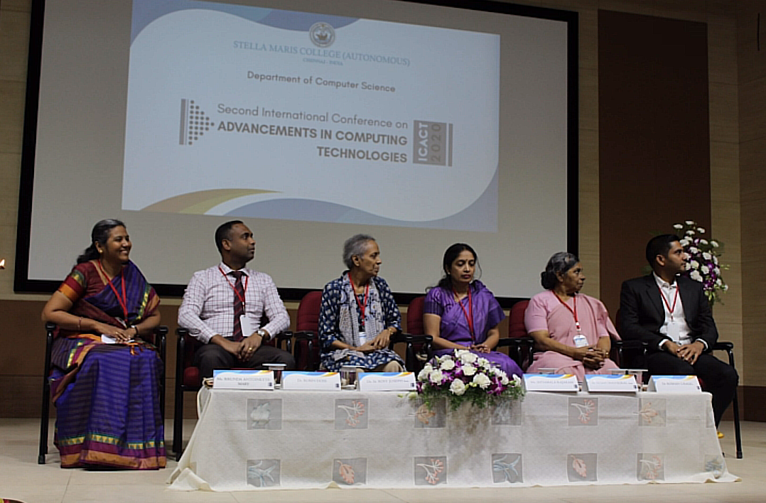

2020

Second International Conference on Advancements in Computing Technologies

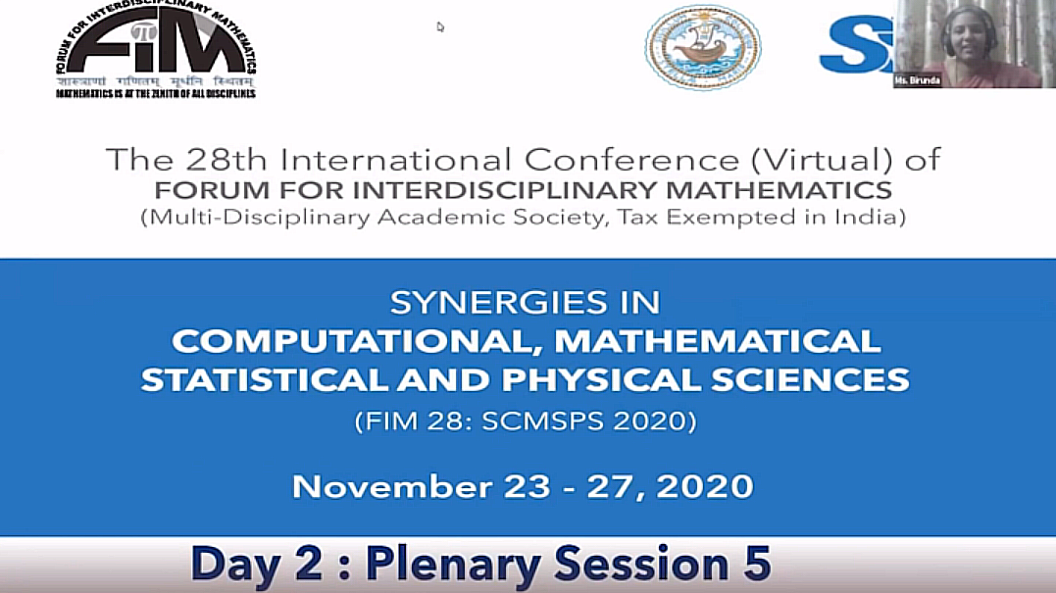

28th International Conference on FIM SCMSPS 2020